## INTRODUCTION

Introduction: Empowering Change in Abbigere In a proactive endeavor to foster environmental consciousness and champion sustainable living, a group of dedicated college students embarked on a transformative journey to Abbigere, a vibrant locality in the heart of Bangalore.

Armed with a collective passion for conservation and a commitment to making a tangible impact, our team initiated an awareness campaign advocating for the use of paper bags over plastic. Abbigere, with its unique blend of urban vibrancy and natural beauty, served as the canvas for our mission.

Recognizing the urgency of reducing plastic consumption for the betterment of our planet, our campaign aimed to instill a profound understanding of the ecological repercussions associated with plastic usage.

The focal point of our efforts was the distribution of eco-friendly paper bags, an earnest call to action encouraging the community to embrace sustainable alternatives. Beyond a simple shift in material, our endeavor sought to magnify the importance of afforestation as a means to combat climate change, enhance biodiversity, and contribute to the overall safety of our planet. This introduction encapsulates the spirit of our initiative—a collective journey to inspire change, one paper bag at a time, in the bustling locality of Abbigere.

Together, we strive for a greener, cleaner future, fostering a community that champions sustainable practices and cherishes the well-being of our shared home—Earth.

## Promoting Paper Bags in Abbigere, Bangalore

### Objective:

The primary objective of our environmental awareness campaign in Abbigere, Bangalore, was to advocate for sustainable practices by distributing paper bags as an alternative to plastic, aiming to foster afforestation and contribute to the overall safety of our planet.



#### Specific Goals:

**Paper Bag Distribution:** Distribute eco-friendly paper bags extensively in Abbigere to replace plastic bags, aiming to reduce plastic consumption and waste.

**Raise Awareness:** Educate the local community about the adverse environmental impacts of plastic pollution, emphasizing the importance of transitioning to sustainable alternatives like paper.

**Afforestation Advocacy:** Promote afforestation initiatives by distributing informational materials and engaging in conversations that highlight the critical role of trees in mitigating climate change and ensuring the planet's safety.

**Behavioral Change:** Encourage a tangible shift in consumer behavior, inspiring individuals to choose paper over plastic for daily use, thereby contributing to a cleaner, healthier environment.

**Community Engagement:** Foster a sense of shared responsibility within the community, creating a dialogue about sustainable practices and motivating residents to actively participate in environmental preservation.

By addressing these objectives, our aim was not only to provide a practical alternative to plastic but also to catalyze a broader cultural shift towards eco-conscious living. Through these efforts, we sought to contribute to the broader mission of creating a more sustainable and secure future for our planet.

### Participants:

A dedicated group of college students, passionate about environmental conservation and sustainability, actively participated in the campaign. The team engaged with the local community, spreading awareness about the harmful effects of plastic and promoting the benefits of adopting paper bags.

### Activities:

1. **Distribution of Paper Bags:** The team distributed eco-friendly paper bags at key locations in Abbigere, emphasizing their advantages over plastic bags. Each bag carried a message encouraging residents to switch to paper for the well-being of the environment.
2. **Community Engagement:** Interactions with local residents were a significant aspect of our campaign. The team engaged in discussions, providing insights into the environmental impact of plastic pollution and the positive implications of using paper.
3. **Afforestation Awareness:** To underline the importance of afforestation, informational pamphlets accompanied the paper bags. These pamphlets highlighted the role of trees in mitigating climate change, promoting biodiversity, and improving overall air quality.

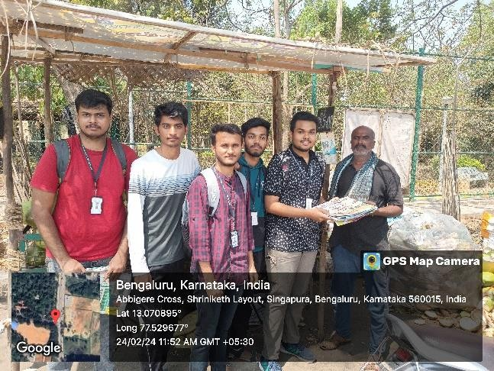

### Response and Impact:

The response from the community was overwhelmingly positive. Residents expressed a heightened awareness of the environmental consequences of plastic usage and a genuine interest in adopting sustainable alternatives. Many community members pledged to reduce their reliance on plastic bags and actively participate in afforestation initiatives.

#### Positive Community Engagement:

Residents of Abbigere exhibited a commendable willingness to engage in discussions about the harmful effects of plastic on the environment. Conversations were marked by genuine curiosity, with many expressing a newfound understanding of the urgent need to transition towards more sustainable alternatives.

#### Adoption of Paper Bags:

The distribution of eco-friendly paper bags yielded tangible results as residents actively incorporated them into their daily lives. Many community members enthusiastically embraced the shift from plastic, recognizing the positive environmental implications and pledging to continue this eco-friendly choice.

#### Afforestation Pledges:

Our campaign's emphasis on afforestation as a solution to environmental challenges resonated deeply with the community. Informational pamphlets distributed alongside the paper bags sparked discussions about the crucial role of trees, leading to pledges from residents to support local afforestation initiatives.

#### Behavioral Change:

The campaign has catalyzed a noticeable behavioral change within the community. Individuals are making conscious decisions to reduce their reliance on plastic, contributing to a cleaner and safer local environment. The sight of residents proudly using paper bags has become a symbol of a collective commitment to sustainable living.

#### Educational Impact:

Beyond immediate actions, the campaign has left a lasting educational impact. Awareness about the environmental consequences of plastic pollution has grown, creating a community that is more informed and empowered to make environmentally conscious choice

### Challenges:

While the majority of residents embraced the initiative, there were challenges in changing ingrained habits. Some individuals were initially resistant to the transition from plastic to paper. However, through open conversations and informative discussions, these challenges were effectively addressed.

#### Challenges Faced:

**Behavioral Resistance:**

Encouraging a shift from entrenched habits proved challenging. Some community members were initially resistant to adopting paper bags, emphasizing the need for persistent education to break through pre-existing norms.

#### Limited Awareness:

Despite our efforts, a segment of the population in Abbigere exhibited limited awareness about the environmental impact of plastic. Overcoming this challenge required targeted educational strategies to convey the urgency of transitioning to more sustainable practices.

#### Communication Barriers:

Language and communication barriers were encountered during interactions with diverse groups in Abbigere. Tailoring our messaging and educational materials to cater to various linguistic and cultural nuances was crucial to effectively convey our environmental message.

#### Long-Term Commitment:

Sustaining community engagement and commitment to eco-friendly practices requires ongoing effort. Ensuring that the momentum gained during the campaign translates into enduring behavioral change poses an ongoing challenge.

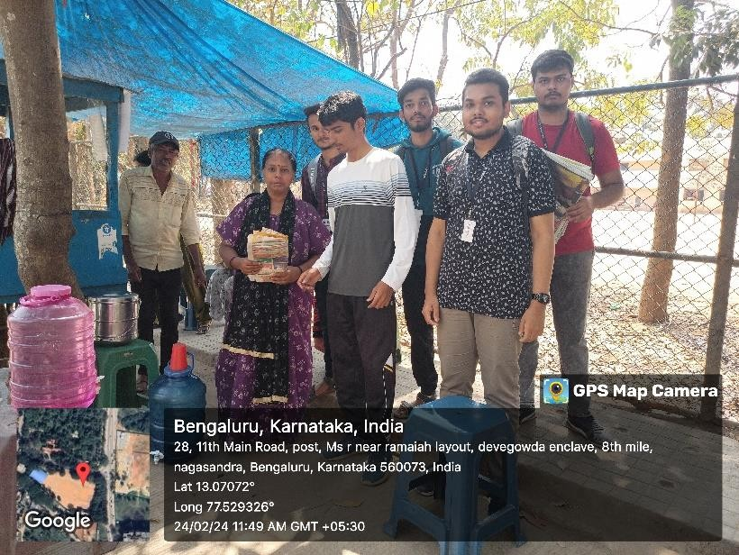

### Conclusion:

The environmental awareness campaign in Abbigere proved to be a significant step towards promoting sustainable practices and reducing plastic pollution. The distribution of paper bags not only provided a tangible alternative but also initiated essential conversations about responsible environmental stewardship. The campaign underscored the power of grassroots initiatives in creating positive change and fostering a sense of collective responsibility for the planet's well-being.

### Conclusion and Impact:

Paving the Path to Sustainability in Abbigere Our venture to Abbigere stands as a testament to the potential of collective action and community engagement in championing environmental sustainability. As a group of college students, our mission to distribute paper bags and raise awareness about the perils of plastic has left an indelible impact on both the community and the local environment.

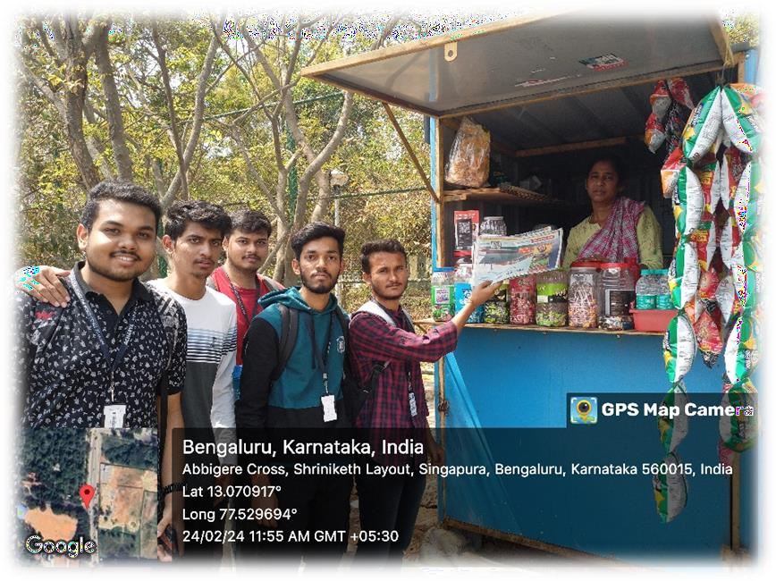

### Immediate Impact:

#### Behavioral Change:

Overcoming initial hesitations, the community exhibited a tangible shift towards embracing paper bags. The visible adoption of eco-friendly alternatives signifies a behavioral change, symbolizing a departure from traditional plastic usage.

#### Afforestation Advocacy:

Conversations sparked during the campaign highlighted the importance of afforestation. Pledges of support for afforestation initiatives indicate a growing understanding of the vital role trees play in safeguarding our planet.

#### Community Empowerment:

The engagement with Abbigere's residents empowered them to become stewards of their environment. The campaign acted as a catalyst for individual and collective responsibility, fostering a sense of agency in making sustainable choices.

### Long-Term Impact:

#### Educational Legacy:

The informational materials shared during the campaign have established an enduring

educational legacy. The community is now equipped with knowledge that transcends the immediate campaign, contributing to sustained environmental consciousness.

#### Cultural Shift:

Beyond the distribution of paper bags, our efforts have initiated a cultural shift towards sustainability. Residents are increasingly mindful of their ecological footprint, embracing practices that align with the broader goal of ensuring a safer and healthier planet.

#### Seed for Future Initiatives:

The campaign has planted the seed for future initiatives and collaborations. By building a foundation of environmental awareness, Abbigere is poised for continued efforts towards sustainable living and ecological preservation.

In conclusion, our journey to Abbigere has been a catalyst for positive change. The impact achieved, both immediate and long-term, speaks to the potential of grassroots initiatives led by passionate individuals. As the echoes of our campaign resonate, we remain hopeful that the seeds of change planted in Abbigere will blossom into a thriving culture of sustainability, contributing to the greater good of our shared home—Earth. The journey continues, propelled by the belief that each small action contributes to a planet that is safer, healthier, and more resilient.

### Recommendations:

#### Sustained Education:

Continued educational initiatives and workshops to reinforce the advantages of paper over plastic.

#### Collaboration with Local Authorities:

Partnering with local authorities for long-term waste management solutions and afforestation programs.

#### Expanding Outreach:

Extending the campaign to neighboring areas to amplify the impact on a broader scale. In conclusion, this campaign serves as a testament to the potential of community-driven efforts in promoting sustainable practices and fostering environmental consciousness.